Visual Programming I

Part 1

|  |  |  |  |  |  |  |
| --- | --- | --- | --- | --- | --- | --- |
| # | Photo | Control Name | Default Event | Attributes | Method | Example # |
| 1 |  | Label | Click | 1. Name 2. Text 3. ForeColor 4. BackColor 5. Font 6. Enabled 7. Visible |  | Example 1 |
| 2 |  | Button | Click | 1. Name 2. Text 3. ForeColor 4. BackColor 5. Font 6. Enabled 7. Visible 8. TabIndex | Focus() | Example 2 |
| 3 |  | TextBox | TextChanged | 1. Name 2. Text 3. ForeColor 4. BackColor 5. BorderStyle 6. Font 7. Enabled 8. Visible 9. TabIndex 10. PassordChar 11. RightToLeft | Focus()  ToString() | Example 3  Example 4 |
| 4 |  | RadioButton | CheckedChanged | 1. Name 2. Text 3. ForeColor 4. BackColor 5. Font 6. Enabled 7. Visible 8. TabIndex 9. Checked | Focus() | Example 5 |
| 5 |  | ListBox | SelectedIndexChanged | 1. Name 2. Text 3. ForeColor 4. BackColor 5. Font 6. Enabled 7. Visible 8. TabIndex 9. SelectionMode 10. Items 11. Sorted | Add()  Insert()  Clear()  CopyTo()  AddRange()  Contains() | Example 6 |

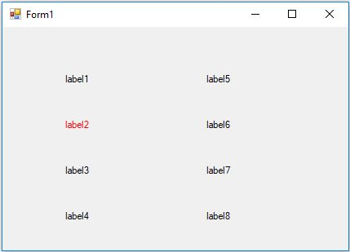

**Example 1 (Label)**

private void label1_Click(object sender, EventArgs e)

{

label1.Text = "Visual Programming";

}

private void label2_Click(object sender, EventArgs e)

{

label2.ForeColor = System.Drawing.Color.Pink;

}

private void label3_Click(object sender, EventArgs e)

{

label3.BackColor = System.Drawing.Color.Pink;

}

private void label4_Click(object sender, EventArgs e)

{

label4.Font = new Font("Arial", 24, FontStyle.Bold);

}

private void label5_Click(object sender, EventArgs e)

{

label6.Enabled = true;

}

private void label6_Click(object sender, EventArgs e)

{

label6.Enabled = false;

}

private void label7_Click(object sender, EventArgs e)

{

label8.Visible = true;

}

private void label8_Click(object sender, EventArgs e)

{

label8.Visible = false;

}

**Example 2 (Button)**

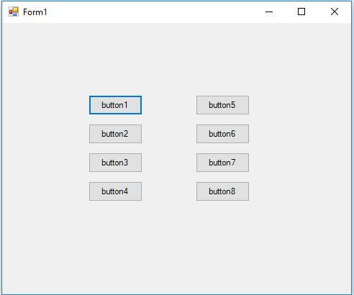

private void button1_Click(object sender, EventArgs e)

{

button1.Text = "VC#";

}

private void button2_Click(object sender, EventArgs e)

{

button2.Font = new Font("Arial", 24, FontStyle.Bold);

}

private void button3_Click(object sender, EventArgs e)

{

button3.BackColor = System.Drawing.Color.Pink;

}

private void button4_Click(object sender, EventArgs e)

{

button4.ForeColor = System.Drawing.Color.Pink;

}

private void button5_Click(object sender, EventArgs e)

{

button6.Enabled = true;

}

private void button6_Click(object sender, EventArgs e)

{

button6.Enabled = false;

}

private void button7_Click(object sender, EventArgs e)

{

button8.Visible = true;

}

private void button8_Click(object sender, EventArgs e)

{

button8.Visible = false;

}

**Example 3 (TextBox)**

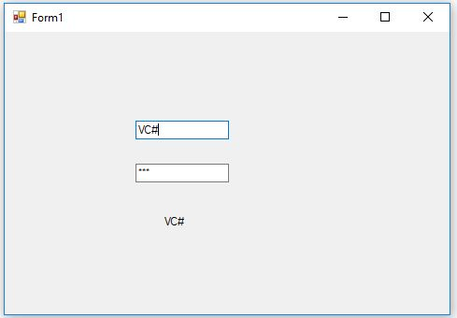

private void textBox1_TextChanged(object sender, EventArgs e)

{

label1.Text = textBox1.Text;

textBox2.Text=textBox1.Text;

}

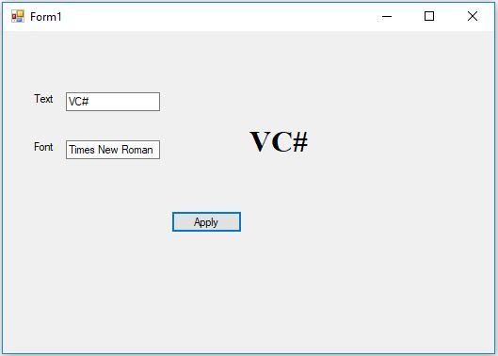**Example 4 (TextBox2)**

private void button1_Click(object sender, EventArgs e)

{

label1.Text = textBox1.Text;

label1.Font = new Font(textBox2.Text.ToString(),24, FontStyle.Bold);

}

**Example 5 (RadioButton)**

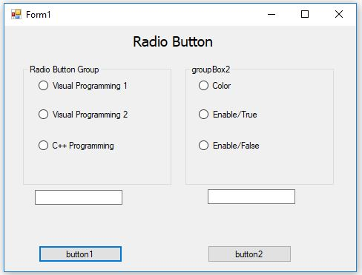

private void radioButton1_CheckedChanged(object sender, EventArgs e)

{

textBox1.Text = radioButton1.Text;

}

private void radioButton2_CheckedChanged(object sender, EventArgs e)

{

textBox1.Text = radioButton2.Text;

radioButton5.Checked = true;

}

private void radioButton3_CheckedChanged(object sender, EventArgs e)

{

textBox1.Text = radioButton3.Text;

}

private void button1_Click(object sender, EventArgs e)

{

if (radioButton1.Checked == true)

textBox1.Text = radioButton1.Text;

else

if(radioButton2.Checked == true)

textBox1.Text = radioButton2.Text;

else

if (radioButton3.Checked )

textBox1.Text = radioButton3.Text;

}

private void button2_Click(object sender, EventArgs e)

{

radioButton5.Checked = false;

}

private void radioButton4_CheckedChanged(object sender, EventArgs e)

{

button2.ForeColor = Color.Yellow;

}

private void radioButton5_CheckedChanged(object sender, EventArgs e)

{

button2.Enabled = true;

}

private void radioButton6_CheckedChanged(object sender, EventArgs e)

{

button2.Enabled = false;

}

**Example 6 (ListBox)**

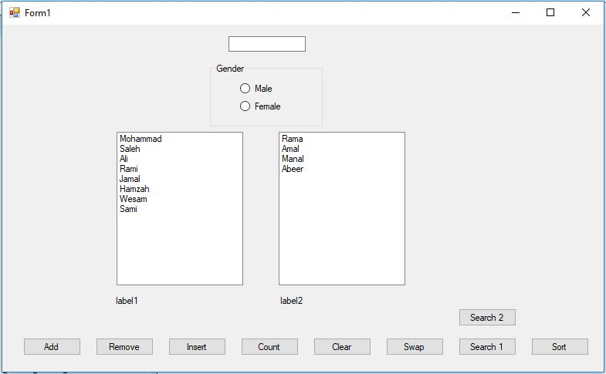

private void button1_Click(object sender, EventArgs e)

{

if (radioButton1.Checked == true)

listBox1.Items.Add(textBox1.Text);

if (radioButton2.Checked == true)

listBox2.Items.Add(textBox1.Text);

}

private void button2_Click(object sender, EventArgs e)

{

if (listBox1.SelectedIndex !=-1)

listBox1.Items.RemoveAt(listBox1.SelectedIndex);

if (listBox2.SelectedIndex != -1)

listBox2.Items.RemoveAt(listBox2.SelectedIndex);

}

private void button3_Click(object sender, EventArgs e)

{

if (listBox1.SelectedIndex != -1)

listBox1.Items.Insert(listBox1.SelectedIndex, textBox1.Text);

if (listBox2.SelectedIndex != -1)

listBox2.Items.Insert(listBox2.SelectedIndex, textBox1.Text);

}

private void button4_Click(object sender, EventArgs e)

{

label1.Text = listBox1.Items.Count.ToString();

label2.Text = listBox2.Items.Count.ToString();

}

private void button5_Click(object sender, EventArgs e)

{

listBox1.Items.Clear();

listBox2.Items.Clear();

}

private void button6_Click(object sender, EventArgs e)

{

string[] temp1 = new string[listBox1.Items.Count];

string[] temp2 = new string[listBox2.Items.Count];

listBox1.Items.CopyTo(temp1, 0);

listBox2.Items.CopyTo(temp2, 0);

listBox1.Items.Clear();

listBox2.Items.Clear();

listBox1.Items.AddRange(temp2);

listBox2.Items.AddRange(temp1);

}

private void button7_Click(object sender, EventArgs e)

{

if (listBox1.Items.Contains(textBox1.Text))

MessageBox.Show("found");

}

private void button8_Click(object sender, EventArgs e)

{

listBox1.Sorted = true;

listBox2.Sorted = true;

}

private void button9_Click(object sender, EventArgs e)

{

for (int x= 0;x< listBox1.Items.Count; x++)

if (textBox1.Text== listBox1.Items[x].ToString())

MessageBox.Show("found "+textBox1.Text+" at index "+(x+1));

}